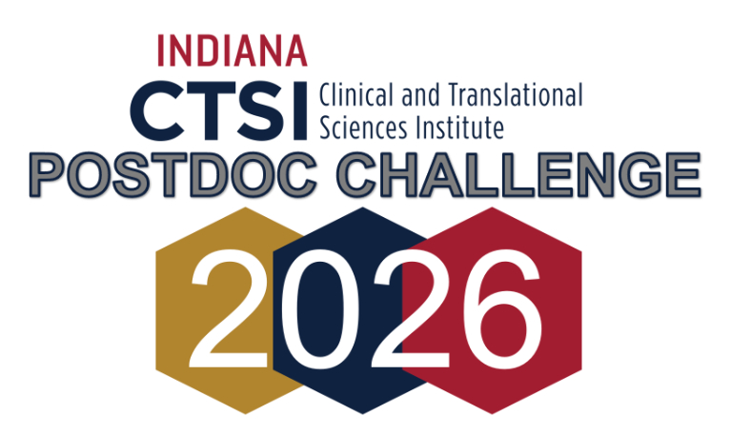
  - Indiana University · Purdue University · University of Notre Dame

Two Ways to Engage – Take part in one or both
Part 1: Apply for a CTSI Core Pilot Grant (up to $5,000)  Funding is for Indiana CTSI-designated core services only. Professional development workshops available to support your application. | Part 2: Serve as a Grant Reviewer  Gain NIH-style peer-review experience with professional development support.
RFA | 
Register to Submit a proposal | 
Register to Review proposals | 

Eligibility
Postdocs and other select non-tenure-track researchers at Indiana University (Bloomington, Indianapolis, School of Medicine & regional campuses), Purdue (West Lafayette, Indianapolis & regional campuses), and the University of Notre Dame. See RFA for more details

Key Dates
Proposal support sessions: Jan/Feb 2026
Proposal deadline: Thursday, March 12, 2026
Reviewer training: Friday, March 20, 2026 · 12–1 PM
Review session: Wednesday, April 15, 2026 · 9:00 AM–1:00 PM (Zoom/Teams)

Indiana Clinical & Translational Sciences Institute (CTSI) · ctsi.indiana.edu | indianactsi.org

