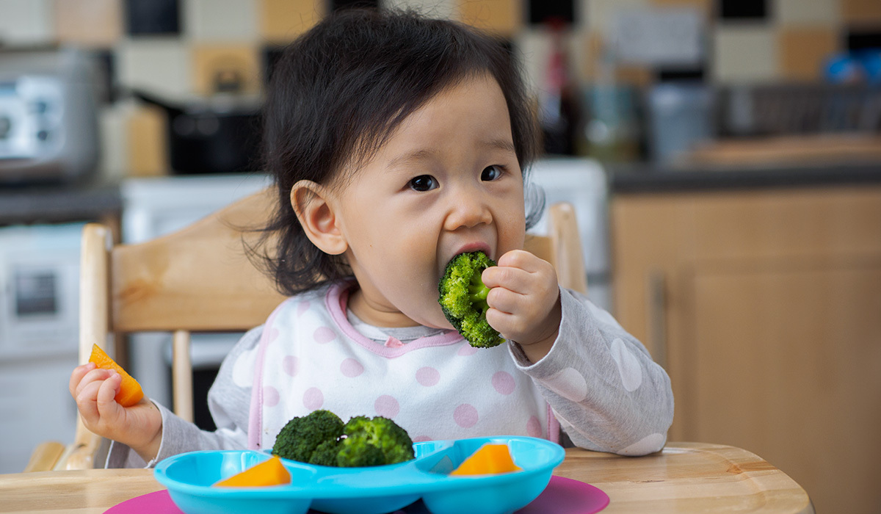

AN INITIATIVE SUPPORTED BY

THE RICKS FAMILY FOUNDATION

THROUGH RILEY CHILDREN’S FOUNDATION

Heartland Children’s

Nutrition Collaborative



**Heartland Children’s**

**Nutrition Collaborative**

AN INITIATIVE SUPPORTED BY

THE RICKS FAMILY FOUNDATION

THROUGH RILEY CHILDREN’S FOUNDATION

Submission Due Date: Thursday, September 12, 2024

Purdue University PIs, Contact **Senay Simsek, PhD** [**ssimsek@purdue.edu**](mailto:ssimsek@purdue.edu)with questions.

Indiana University School of Medicine PIs, Contact **Carmella Evans-Molina, MD, PhD** [**CDMD@iu.edu**](mailto:CDMD@iu.edu) with questions.

WebCAMP portal, Contact **Julie Driscol** [judrisco@iu.edu](mailto:judrisco@iu.edu) with questions.

**UPLOAD** via the Start a Submission [CTSI CDMD Nutrition Link](https://indianactsi.org/researchers/services-tools/translational-research-development/open-funding-opportunities/#IUPUN202409)

*If awarded, this will be considered* ***internal funding for both IU and Purdue*** *applicants and submission does not require prior approval from ORA or Purdue Pre-Award prior to submitting through WebCAMP.*

**HEARTLAND CHILDREN’S NUTRITION COLLABORATIVE**

**2024 APPLICATION**

**FOR APPLICATIONS FROM CO-PIs, INFORMATION AND SIGNATURES MUST REPRESENT BOTH PIs**

**IU PRINCIPAL INVESTIGATOR:**  **EMAIL:**

**RANK, DEPARTMENT, and SCHOOL:**

**INSTITUTIONAL EIN or DUNS NUMBER:**

**IU ADDRESS WHERE WORK WILL BE PERFORMED:**

**PURDUE INVESTIGATOR**  **EMAIL:**

**RANK, DEPARTMENT, and SCHOOL:**

**INSTITUTIONAL EIN or DUNS NUMBER:**

**TITLE OF PROPOSAL:**

**PURDUE ADDRESS WHERE WORK WILL BE PERFORMED:**

**BUDGET PERIOD (maximum 12 months):**

From: (Month/Day/Year) To:(Month/Day/Year)

AMOUNT REQUESTED:

Total $ (may not exceed $200,000 in total; indirect costs are not allowed)

APPROVAL

YES NO PROTOCOL # DATE

BIOSAFETY/IBC?

HUMAN SUBJECTS?

VERTEBRATE ANIMALS?

DOES THIS PROJECT INVOLVE CLINICAL RESEARCH?

**IU REQUIRED SIGNATURES: The undersigned agree(s) to accept responsibility for the scientific and technical conduct of the research project and for provision of required progress reports if a grant is awarded as the result of this application.**

**APPLICANT SIGNATURE:** __________________________________________________________________________

**TYPED NAME AND TITLE OF APPLICANT:** ____________________________________________________________

**DEPARTMENTAL OFFICIAL SIGNATURE*:** ____________________________________________________________

*By this signature you are attesting to approval and support of the time and effort specified by the PI on this application.

**TYPED NAME OF DEPARTMENTAL OFFICIAL:** ________________________________________________________

**Co-APPLICANT SIGNATURE (if applicable):** ___________________________________________________________

**TYPED NAME AND TITLE OF APPLICANT:** ____________________________________________________________

**DEPARTMENTAL OFFICIAL SIGNATURE*:** ____________________________________________________________

*by this signature you are attesting to approval and support of the time and effort specified by the PI on this application.

**TYPED NAME OF DEPARTMENTAL OFFICIAL:** ________________________________________________________

**PU REQUIRED SIGNATURES: The undersigned agree(s) to accept responsibility for the scientific and technical conduct of the research project and for provision of required progress reports if a grant is awarded as the result of this application.**

**APPLICANT SIGNATURE:** __________________________________________________________________________

**TYPED NAME AND TITLE OF APPLICANT:** ____________________________________________________________

**DEPARTMENTAL OFFICIAL SIGNATURE*:** ____________________________________________________________

*By this signature you are attesting to approval and support of the time and effort specified by the PI on this application.

**TYPED NAME OF DEPARTMENTAL OFFICIAL:** ________________________________________________________

**Co-APPLICANT SIGNATURE (if applicable):** ___________________________________________________________

**TYPED NAME AND TITLE OF APPLICANT:** ____________________________________________________________

**DEPARTMENTAL OFFICIAL SIGNATURE*:** ____________________________________________________________

*by this signature you are attesting to approval and support of the time and effort specified by the PI on this application.

**TYPED NAME OF DEPARTMENTAL OFFICIAL:** ________________________________________________________

**Cover Page:**

* Proposal Title
* Principal investigators' names and affiliations
* Please note eligible investigators will have a primary or secondary affiliation in the following Departments or Centers:
  + IU School of Medicine Department of Pediatrics
  + Members of the Child Health Research Institute
  + Members of the Indiana Diabetes Research Center
  + PU The College of Agriculture
  + PU Biomedical Engineering
  + PU Nutrition Department
* Eligible teams must have at least one IU and one Purdue investigator.
* IUSM: All faculty at or above the Assistant Professor level; all research professors; all clinical faculty (assuming they meet all other eligibility criteria)
* Purdue: All tenured or tenure-track West Lafayette faculty at or above the Assistant Professor level; all research professors; all clinical faculty; Non-faculty approved must seek approval from the Dean of the College of Agriculture (assuming they meet all other eligibility criteria)

**Scientific Proposal** (max 3 pages, not including references): Please include relevant background, Specific Aims, and a brief description of methods, including a discussion of pitfalls and alternatives. Preliminary data is not required, but it will be accepted.

**Milestones and Deliverables**: Detail expected outcomes for the project, including a plan for submission of external funding applications. (max 1 page)

**Budget** (Template below): A detailed breakdown of the anticipated expenses for the project, including personnel salaries, equipment costs, travel expenses, and any other relevant costs.

1. **Purdue Budget**

**Personnel** (acceptable personnel include technicians, research staff, and students. Faculty salary should not exceed 10% of total budget allowed)

**Supplies** (Specify expected reagents and supply costs and quantities)

**Core Facilities Usage** (included hourly rates, expected hours, etc.)

**Travel** (The travel budget proposed must be clearly specified for how it relates to the proposed project)

1. **IU Budget**

**Personnel** (acceptable personnel include technicians, research staff, and students. Faculty salary should not exceed 10% of total budget allowed)

**Supplies** (Specify expected reagents and supply costs and quantities)

**Core Facilities Usage** (included hourly rates, expected hours, etc.)

**Travel** (The travel budget proposed must be clearly specified for how it relates to the proposed project)

**Required Additional Pages (Appendices)**

* **Key Personnel**
* **Other Support** for each key personnel
* **NIH Biosketch** for each key personnel in new format, limited to 5 pages each
* **Description of Facilities and Resources** available to the applicant
* **Budget** in NIH format with budget justification

1. Supplies and costs must relate directly to the performance of the project.
2. Travel should be limited to the amount necessary to achieve the aims of the project.
3. No-cost extensions will not be awarded.

* **Approved current institutional vertebrate animal care form** (if applicable)
* **Approved current institutional human subjects selection criteria form** (if applicable)
* **Supporting documentation** (if applicable)
  + 1. 5 page limit
    2. Could include but not limited to manuscript text, abstracts, links, unique figures, etc.

Principal Investigator (Last, first, middle):

|  |  |  |  |  |  |  |  |  |  |
| --- | --- | --- | --- | --- | --- | --- | --- | --- | --- |
| Principal Investigator/Program Director (Last, First, Middle): | | |  | | | | | | |
|  | | | | | | | | | |
| SENIOR / KEY PERSONNEL REPORT | | | | Project Title | | | | | |
| All Senior / Key Personnel for the one year budget period must be listed below. | | | | | | | | | |
| Name | Degree(s) | Role on Project (e.g. PI, Res. Assoc.) | | | Institutional Affiliation | Effort Devoted to Project | | |
| Cal | Acad | Sum |
|  |  |  | | |  |  |  |  | |
|  |  |  | | |  |  |  |  | |
|  |  |  | | |  |  |  |  | |
|  |  |  | | |  |  |  |  | |
|  |  |  | | |  |  |  |  | |
|  |  |  | | |  |  |  |  | |
|  |  |  | | |  |  |  |  | |
|  |  |  | | |  |  |  |  | |
|  |  |  | | |  |  |  |  | |
|  |  |  | | |  |  |  |  | |
|  |  |  | | |  |  |  |  | |
|  |  |  | | |  |  |  |  | |
|  |  |  | | |  |  |  |  | |
|  |  |  | | |  |  |  |  | |
|  |  |  | | |  |  |  |  | |
|  |  |  | | |  |  |  |  | |
|  |  |  | | |  |  |  |  | |
|  |  |  | | |  |  |  |  | |
|  |  |  | | |  |  |  |  | |
|  |  |  | | |  |  |  |  | |
|  |  |  | | |  |  |  |  | |
|  |  |  | | |  |  |  |  | |
|  |  |  | | |  |  |  |  | |
|  |  |  | | |  |  |  |  | |
|  |  |  | | |  |  |  |  | |
|  |  |  | | |  |  |  |  | |
|  |  |  | | |  |  |  |  | |
|  |  |  | | |  |  |  |  | |
|  |  |  | | |  |  |  |  | |
|  |  |  | | |  |  |  |  | |
|  |  |  | | |  |  |  |  | |
|  |  |  | | |  |  |  |  | |

|  |  |  |  |
| --- | --- | --- | --- |
|  |  |  |  |

Please refer to NIH [Biosketch Format Pages, Instructions and Samples | grants.nih.gov](https://grants.nih.gov/grants/forms/biosketch.htm) and [Other Support | grants.nih.gov](https://grants.nih.gov/grants/forms/othersupport.htm) for information on completing the biographical sketch pages and other support pages.

**Description of Facilities and Resources**

Principal Investigator (Last, first, middle): **YEAR 1**

|  |  |  |  |  |  |  |  |  |  |  |
| --- | --- | --- | --- | --- | --- | --- | --- | --- | --- | --- |
| **DETAILED BUDGET FOR YEAR 1 BUDGET PERIOD**  **DIRECT COSTS ONLY** | | | | | | FROM  January 1, 2025 | | THROUGH  January 1, 2026 | | |
| PERSONNEL *(Applicant organization only)* | |  | % |  | DOLLAR AMOUNT REQUESTED *(omit cents)* | | | | | |
| NAME | ROLE ON  PROJECT | TYPE  APPT.  *(months)* | EFFORT  ON  PROJ. | INST.  BASE  SALARY | SALARY  REQUESTED | | FRINGE  BENEFITS | | | TOTAL |
|  | Principal  Investigator |  |  |  |  | |  | | |  |
|  | Collaborator |  |  |  |  | |  | | |  |
|  |  |  |  |  |  | |  | | |  |
|  |  |  |  |  |  | |  | | |  |
|  |  |  |  |  |  | |  | | |  |
|  |  |  |  |  |  | |  | | |  |
|  |  |  |  |  |  | |  | | |  |
| **SUBTOTALS** | | | | |  | |  | | |  |
| CONSULTANT COSTS | | | | | | | | | |  |
| SUPPLIES | | | | | | | | | |  |
| TRAVEL | | | | | | | | | |  |
| PATIENT CARE COSTS | | | | | | | | | |  |
| OTHER EXPENSES | | | | | | | | | |  |
| TOTAL DIRECT COSTS FOR YEAR 1 BUDGET PERIOD | | | | | | | | |  | |

BUDGET JUSTIFICATION: