Key Considerations for Participant-Centered Study Recruitment

Recruiting for research is difficult. These are some best practices to help researchers improve the participant-centeredness of their research study recruitment efforts. Recruitment is about building trust and this is achieved through listening and responding to your participant audience.
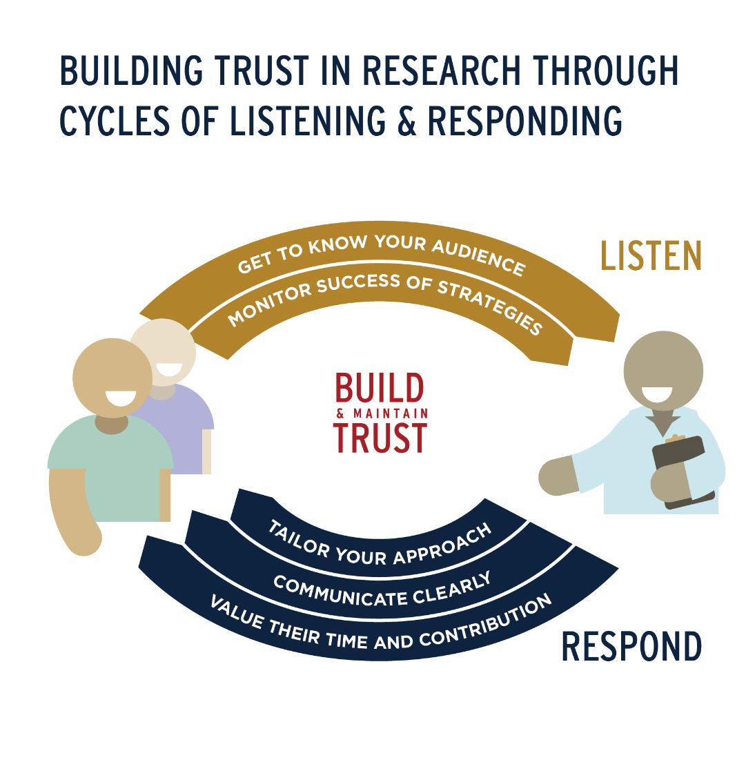
LISTEN
Get to know your audience
Monitor success of strategies

RESPOND
Tailor your approach
Communicate clearly
Value their time and contribution

Listen

GET TO KNOW YOUR AUDIENCE

Plan your recruitment and engagement strategies with people representing your target population.
Recruit community members, patients, and other stakeholders to help you plan your engagement strategy, give feedback on study materials, and connect you with trusted people in the community who can help you with outreach. This step requires additional time and budget, but will help you make an informed plan for your recruitment and engagement strategy. It also gives you a resource for trouble-shooting recruitment challenges.
EXAMPLES
- Indiana CTSI Research Jam projects: PowerHouse Program and materials, INgenious Study and Youth Contraception Navigator Study
- Community Advisors on Research Design and Strategies (CARDS)
- Case Study: Diverse Patient Engagement at a Pharmaceutical Company
- The Triple Negative Breast Cancer Disease Research team at Indiana University has partnered with RED Alliance and Pink-4-Ever on recruitment planning and implementation for the EAZ717 trial. This study is sponsored by ACOG-ACRIN cancer research group and NCI. In addition, the team partners with advocacy group the Inflammatory Breast Cancer Research Foundation, who advises them in trial development, recruitment, and translating trial results back to patients.

RESOURCES
- Indiana CTSI’s Research Jam
- The Value of Patient Advisory Boards from Patient-Centered Outcomes Research Institute

REFERENCES
- Abshire, M., Dinglas, V.D., Cajita, M.I.A. et al. Participant retention practices in longitudinal clinical research studies with high retention rates. BMC Med Res Methodol 17, 30 (2017). https://doi.org/10.1186/s12874-017-0310-z
- Horowitz CR, Sabin T, Ramos M, Richardson LD, Hauser D, Robinson M, Fei K. Successful recruitment and retention of diverse participants in a genomics clinical trial: a good invitation to a great party. Genet Med. 2019 Oct;21(10):2364-2370. doi: 10.1038/s41436-019-0498-x. Epub 2019 Apr 5. PMID: 30948857.

Highlight compelling reasons participants may care about your study.
Altruism is a major motivator for research participation. Be sure to highlight how your study will help people now and in the future. Consider other motivators for participating—such as access to treatments, the opportunity to learn something new, and financial compensation—and highlight these in your materials.
EXAMPLES
- Total Cancer Care at the Indiana University Melvin and Bren Simon Comprehensive Cancer Center
- The brochure for the FIT Study at the Indiana University Center for Musculoskeletal Health.

RESOURCES
- Common reasons for participating:
  - Promoting scientific understanding or learning something new about health topics from participating
  - Improving their own health
  - Improving prevention, treatment, understanding or survival for people with a certain disease
  - Helping others, helping future generations
  - Study topic relevant to the individual’s health or the health of family/friends
  - Free healthcare
  - Access to new therapies
  - Financial compensation

REFERENCES
- Kost, R.G., Lee, L.M., Yessis, J., Coller, B.S., Henderson, D.K. and (2011), Assessing Research Participants’ Perceptions of their Clinical Research Experiences. Clinical and Translational Science, 4: 403-413. https://doi.org/10.1111/j.1752-8062.2011.00349.x
- PCORI We Enact Tool
- Indiana CTSI Research Jam – Precision Health Indiana State Fair Data Collection

Build a relationship with participants.
Get to know your participants and build rapport. Hire recruiters and consenters who are personable, respectful, and organized. Consider small personal tokens such as birthday and holiday cards as part of your study follow-up or reminder strategy. Establish Trust (Respecting privacy, letting them know that they can change their minds, informing them of new information, monitoring their welfare). Be a good host (be on time, welcoming, appreciative, appropriate environment). Watch your body language, eye contact, and tone of voice. Know the name of the participant you are meeting with.

EXAMPLES
- Persevere Trial Facebook page
- Final Manifesto for Ethical Research in the Downtown Eastside (see especially the Getting to Know Each Other section)

RESOURCES
- C. Algeo (2013) The Researcher-Participant Relationship in Action Research: A Case Study Involving Australian Project Managers, ICERI2013 Proceedings, pp. 6042-6049.
- How to Build Better Rapport for Better Research Interviews by Michael Margolis

REFERENCES
- Guiding Principles for Ethical Research. Pursuing Potential Research Participants Protections. National Institute of Health. March 2016.
- Melody S. Goodman, PhD, Vetta L. Sanders Thompson, PhD, The science of stakeholder engagement in research: classification, implementation, and evaluation, Translational Behavioral Medicine, Volume 7, Issue 3, September 2017, Pages 486–491, https://doi.org/10.1007/s13142-017-0495-z
- Horowitz CR, Sabin T, Ramos M, Richardson LD, Hauser D, Robinson M, Fei K. Successful recruitment and retention of diverse participants in a genomics clinical trial: a good invitation to a great party. Genet Med. 2019 Oct;21(10):2364-2370. doi: 10.1038/s41436-019-0498-x. Epub 2019 Apr 5. PMID: 30948857.

MONITOR THE SUCCESS OF YOUR STRATEGIES

Evaluate your recruitment and engagement strategies.
Ask people to share why they declined to participate in order to identify improvements you could make to your process and/or materials. Track where participants heard about your study so you can see which sources are working best. Evaluate how participants feel about your study and their experience in your study.
EXAMPLES
- Krusche A, Rudolf von Rohr I, Muse K, Duggan D, Crane C, Williams JMG. An evaluation of the effectiveness of recruitment methods: The staying well after depression randomized controlled trial. Clinical Trials. 2014;11(2):141-149. doi:10.1177/1740774514521905
- Gaupp-Berghausen M, Raser E, Anaya-Boig E, Avila-Palencia I, de Nazelle A, Dons E, Franzen H, Gerike R, Götschi T, Iacorossi F, Hössinger R, Nieuwenhuijsen M, Rojas-Rueda D, Sanchez J, Smeds E, Deforth M, Standaert A, Stigell E, Cole-Hunter T, Int Panis L. Evaluation of Different Recruitment Methods: Longitudinal, Web-Based, Pan-European Physical Activity Through Sustainable Transport Approaches (PASTA) Project. J Med Internet Res 2019;21(5):e11492. doi: 10.2196/11492
- Culshaw, S. (2020). YouTube as a Recruitment Tool? A Reflection on Using Video to Recruit Research Participants, Video Journal of Education and Pedagogy, 5(1), 1-19. doi: https://doi.org/10.1163/23644583-00501004

RESOURCES
- Google analytics
- Indiana CTSI Translational Informatics Program
- RedCap
- Qualtrics
- Social media recruitment tools such as Facebook ads will generally have analytics that you can use

REFERENCES
- Horowitz CR, Sabin T, Ramos M, Richardson LD, Hauser D, Robinson M, Fei K. Successful recruitment and retention of diverse participants in a genomics clinical trial: a good invitation to a great party. Genet Med. 2019 Oct;21(10):2364-2370. doi: 10.1038/s41436-019-0498-x. Epub 2019 Apr 5. PMID: 30948857.
- Doshi, A., Connally, L., Johnson, A., & Skrzypek, A. (2021). Creating a centralized social media recruitment service for research teams at the University of Michigan. Journal of Clinical and Translational Science, 5(1), E47. doi:10.1017/cts.2020.540
- Indiana CTSI Research Jam Participant Feedback Survey

Respond

TAILOR YOUR APPROACH
Customize your approach based on the study population and the individual.
Plan for flexibility in your delivery of recruitment and consent information. Make the information relevant to the participant or study population based on what you know about them. Consider their cultural background, education level, cognitive ability, age, values, preferences, location (both physical and online), etc.
EXAMPLES
- Tailoring Vaccine Trial Recruitment to Individual Communities

RESOURCES
- Health Equity and Racial Justice Taskforce at Indiana CTSI
- Diversity, Inclusion, and Equity in Clinical Research from the Multi-Regional Clinical Trials Center
- Including Pediatric Populations in Research: Challenges and Strategies for Recruitment from the Oregon Clinical and Translational Research Institute
- Study Recruitment: Using Digital Tools to Increase Participation from the Ohio State University Center for Clinical and Translational Science
- Social Media Fact Sheet from Pew Research Center
- Facebook ads
- Instagram ads
- YouTube ads
- Snapchat ads

REFERENCES
- Khodyakov, Dmitry, Elizabeth Bromley, Sandra Kay Evans, and Katharine Sieck, Best Practices for Participant and Stakeholder Engagement in the All of Us Research Program. Santa Monica, CA: RAND Corporation, 2018. https://www.rand.org/pubs/research_reports/RR2578.html.

Diversify your staff to meet your recruitment needs.
Consider hiring staff who have similar characteristics to your target population. For example, if you are recruiting Black Women, consider hiring a Black woman to recruit. Particularly if your team works with participants of various racial and cultural backgrounds, hiring a diverse staff will allow for flexibility and improved ability to anticipate nuances in cultural attitudes that may affect your study recruitment.
EXAMPLES
- Increasing diversity at investigator sites could increase minority participation in clinical trials

RESOURCES
- A Toolkit for Recruiting and Hiring a More Diverse Workforce

REFERENCES
- Horowitz CR, Sabin T, Ramos M, Richardson LD, Hauser D, Robinson M, Fei K. Successful recruitment and retention of diverse participants in a genomics clinical trial: a good invitation to a great party. Genet Med. 2019 Oct;21(10):2364-2370. doi: 10.1038/s41436-019-0498-x. Epub 2019 Apr 5. PMID: 30948857.
- Getz K, Faden L. Racial disparities among clinical research investigators. Am J Ther. 2008 Jan-Feb;15(1):3-11. doi: 10.1097/MJT.0b013e31815fa75a. PMID: 18223347.

Recruit through community partners trusted by your target population.
Build and utilize connections with community partners to spread recruitment messages and solicit engagement ideas. These can include community organizations, trusted individuals in the community, physicians, school staff, etc. Identify participants who are particularly invested in the study, ask for their advice, and empower them to spread the word. A good community partner would share common missions/goals, promote diversity, and have a genuine interest in the community.

EXAMPLES
- Health Equity, Urban Congregations, and HIP Study
- The Triple Negative Breast Cancer Disease Research team at Indiana University has partnered with RED Alliance and Pink-4-Ever on recruitment planning and implementation for the EAZ717 trial. This study is sponsored by ACOG-ACRIN cancer research group and NCI. In addition, the team partners with advocacy group the Inflammatory Breast Cancer Research Foundation, who advises them in trial development, recruitment, and translating trial results back to patients.

- RESOURCES
- IUPUI Community Engagement Directory: https://engage.iupui.edu/partner/Community-Engagement-Directory/index.html
- Indiana CTSI Community Health Partnerships: https://indianactsi.org/community/chep/
- United Way of Central Indiana: https://uwci.org/
- March of Dimes. Making a Community Partnership Work: A Toolkit. 2007. https://www.aapcho.org/wp/wp-content/uploads/2012/02/Giachello-MakingCommunityPartnershipsWorkToolkit.pdf76y
- Community Health Worker Training by University of Illinois Chicago Center for Clinical and Translational Science
- Building Effective Multi-Stakeholder Research Teams by the Patient-Centered Outcomes Research Institute.

REFERENCES
- Abshire, M., Dinglas, V.D., Cajita, M.I.A. et al. Participant retention practices in longitudinal clinical research studies with high retention rates. BMC Med Res Methodol 17, 30 (2017). https://doi.org/10.1186/s12874-017-0310-z
- Horowitz CR, Sabin T, Ramos M, Richardson LD, Hauser D, Robinson M, Fei K. Successful recruitment and retention of diverse participants in a genomics clinical trial: a good invitation to a great party. Genet Med. 2019 Oct;21(10):2364-2370. doi: 10.1038/s41436-019-0498-x. Epub 2019 Apr 5. PMID: 30948857.
- Khodyakov, Dmitry, Elizabeth Bromley, Sandra Kay Evans, and Katharine Sieck, Best Practices for Participant and Stakeholder Engagement in the All of Us Research Program. Santa Monica, CA: RAND Corporation, 2018. https://www.rand.org/pubs/research_reports/RR2578.html.

COMMUNICATE CLEARLY

Ensure your organization has a trustworthy reputation and lean on this reputation.
The reputation of your organization in the community is important for your study. Help ensure you are cultivating a reputation of trust and leverage the trust your organization has in the community by including institutional logos and other resources in your study.
EXAMPLES
- Indiana Precision Health Initiative Person to Person Health Interview Study
  - https://precisionhealth.iu.edu/get-involved/person-to-person.html

RESOURCES
- IU Branded Templates and logos
- Indiana CTSI and partner logos

REFERENCES
- Guillemin M, Barnard E, Allen A, et al. Do Research Participants Trust Researchers or Their Institution? Journal of Empirical Research on Human Research Ethics. 2018;13(3):285-294. doi:10.1177/1556264618763253
- Indiana CTSI Research Jam – Precision Health Indiana State Fair Data Collection

Spend time creating study materials that are clear, concise, and well-designed so that participants are attracted and well-informed.
Create a name, logo, and visual identity to apply to all of your study materials. Use best-practices for reading level, word count, page layout, typography, graphic design, etc. Hire professional writers and visual communicators (graphic designers, social media managers, videographers, etc.) if your budget allows. Test your materials with people representing your study population and with your recruiters/consenters to make sure they work well. In particular, ensure that study steps and risks are clear. Test understanding of your consent form before you use it. Add this development stage to your grant proposals.
EXAMPLES
- Indiana CTSI / IU Health Biobank Project (Consent design, testing, and informed consent evaluation)
- Indiana CTSI Research Jam & Design Corps - recruitment and consent deliverables across various projects (notably the Person to Person Health Interview Study, INgenious Study, Indiana Myeloma Registry)
- Can Lay Community Advisors Improve the Clarity of Research Participant Recruitment Materials and Increase the Likelihood of Participation? https://pubmed.ncbi.nlm.nih.gov/27686332/
- All of Us Research Program communication materials
- The materials, for example the tri-fold brochure and two-page flyer, for the EAZ717 trial were co-developed with RED Alliance, Pink-4-Ever and the Inflammatory Breast Cancer Research Foundation.
- The brochure and social media image for the FIT Study at the Indiana University Center for Musculoskeletal Health.

RESOURCES
Hire a local graphic designer if your budget allows. Or, if you want to do it yourself, here are some resources:
Writing
- The Science of Scientific Writing by George Gopen and Judith Swan
- UpGoer 5 Text Editor
- Microsoft Word readability features
- Plain Language from the National Institutes of Health
- Plain Language Thesaurus for Health Communication
- Health Literacy Checklist for Research Communication from the Oregon Clinical and Translational Research Institute
- Plain Language Medical Dictionary Application by the University of Michigan Library
Design
- 5 typography rules for non-designers
- Butterick’s Practical Typography
- Essential Graphics/Design Concepts for Non-Designers by Ana Henke
- Color Basics and Visual Design Basics from usability.gov
- Visual Design and Usability Yellow Brick Road and Think Outside the Box, but Don’t Foroget the Box Exists by Tammy Guy
Art sources
Note: always check the license to make sure you are using the art appropriately. You may need to give credit to the original creator or you may not be allowed to use it for commercial purposes, for example. Read the license carefully and follow the rules. Do not use art that you don’t have permission to use or if you are unsure of the license.
- Creative Commons [free, some restrictions depending on license]
- The Noun Project [some free with attribution to creator, others paid]
- Shutterstock [paid]
- Death to Stock [paid]
- Unsplash [free, use for any purpose, no attribution]
- Adobe Stock [standard content free through IU. You can also request premium content credits. - log in with IU credentials, some restrictions depending on license]

Templates
- IU Branded Templates
- Indiana CTSI and partner logos

Assistance
- Indiana CTSI’s Research Jam’s Design Services

REFERENCES
- Kost, R.G., Lee, L.M., Yessis, J., Coller, B.S., Henderson, D.K. and (2011), Assessing Research Participants’ Perceptions of their Clinical Research Experiences. Clinical and Translational Science, 4: 403-413. https://doi.org/10.1111/j.1752-8062.2011.00349.x
- Abshire, M., Dinglas, V.D., Cajita, M.I.A. et al. Participant retention practices in longitudinal clinical research studies with high retention rates. BMC Med Res Methodol 17, 30 (2017). https://doi.org/10.1186/s12874-017-0310-z
- Horowitz CR, Sabin T, Ramos M, Richardson LD, Hauser D, Robinson M, Fei K. Successful recruitment and retention of diverse participants in a genomics clinical trial: a good invitation to a great party. Genet Med. 2019 Oct;21(10):2364-2370. doi: 10.1038/s41436-019-0498-x. Epub 2019 Apr 5. PMID: 30948857.
- Doshi, A., Connally, L., Johnson, A., & Skrzypek, A. (2021). Creating a centralized social media recruitment service for research teams at the University of Michigan. Journal of Clinical and Translational Science, 5(1), E47. doi:10.1017/cts.2020.540
- Indiana CTSI / IU Health Biobank Project (Consent design, testing, and informed consent evaluation) (Paper Forthcoming)

VALUE THEIR TIME AND CONTRIBUTION

Highlight that you will return results if you plan to do so (and try to do so).
Receiving personal results of clinical tests is a selling point for participants. In addition, receiving the overall results of the study is also a selling point. If you plan to do either of these things, include this in the recruitment and consent information. Participants like to hear how the study is going and what the results are.
Study participants in interventional clinical trials should be made aware of study results before they are published. At the participants last study visit, tell them how you plan to share study results and when you think study results will be available. Verify the participant's mailing address/contact information at the last study visit. Once data analysis is complete, communication should occur with participants to unblind them regarding study medication/procedures and discuss the results of the study. Individual phone calls with the principal investigator and participant may be necessary as the participant may have questions regarding the treatment they received and next steps of continuing treatment if necessary/applicable. Tell the participants how they can access the published study results i.e., clinicaltrials.gov.

EXAMPLES
- Health Equity, Urban Congregations, and HIP Study Report and Video
- All of Us Research Program’s participant results
- 2019 Cystic Fibrosis Foundation Patient Registry Highlights

RESOURCES
- A Checklist for Communicating Science and Health Research to the Public by National Institutes of Health
- Dissemination of Research Results by the Vanderbilt Institute for Clinical and Translational Research

REFERENCES
- Clearly Communicating Research Results Across the Clinical Trials Continuum https://www.nih.gov/health-information/nih-clinical-research-trials-you/clearly-communicating-research-results-across-clinical-trials-continuum
- Kost, R.G., Lee, L.M., Yessis, J., Coller, B.S., Henderson, D.K. and (2011), Assessing Research Participants’ Perceptions of their Clinical Research Experiences. Clinical and Translational Science, 4: 403-413. https://doi.org/10.1111/j.1752-8062.2011.00349.x
- Indiana CTSI Research Jam – Precision Health Indiana State Fair Data Collection

Make the consent and study process as low-burden as possible for participants.
Make the process as quick and painless as possible. But remember, do not skip over key elements of the consent that the participant should know and understand. Adapt as necessary to make the process work smoothly for participants. Send the consent to the participant prior to discussing it over the phone/in person. Have flexible options for contacting participants (phone call, text, email, etc.) and a flexible schedule for study visits.
EXAMPLES
- Research Jam and Dr. Tracey Wilkinson - Youth Contraception Navigator online consent

RESOURCES
- Key elements of informed consent: Part 50.25 https://www.ecfr.gov/cgi-bin/text-idx?SID=31042205817afb0b7dcd59f9bbab69c4&mc=true&node=pt21.1.50&rgn=div5#se21.1.50_125
- Using RedCap for eConsent from Vanderbilt Institute for Clinical and Translational Research

REFERENCES
- Kost, R.G., Lee, L.M., Yessis, J., Coller, B.S., Henderson, D.K. and (2011), Assessing Research Participants’ Perceptions of their Clinical Research Experiences. Clinical and Translational Science, 4: 403-413. https://doi.org/10.1111/j.1752-8062.2011.00349.x
- Khodyakov, Dmitry, Elizabeth Bromley, Sandra Kay Evans, and Katharine Sieck, Best Practices for Participant and Stakeholder Engagement in the All of Us Research Program. Santa Monica, CA: RAND Corporation, 2018. https://www.rand.org/pubs/research_reports/RR2578.html.
- Horowitz CR, Sabin T, Ramos M, Richardson LD, Hauser D, Robinson M, Fei K. Successful recruitment and retention of diverse participants in a genomics clinical trial: a good invitation to a great party. Genet Med. 2019 Oct;21(10):2364-2370. doi: 10.1038/s41436-019-0498-x. Epub 2019 Apr 5. PMID: 30948857.
- Moore CM, Wiehe SE, Lynch DO, Claxton GE, Landman MP, Carroll AE, Musey PI. Methicillin-Resistant Staphylococcus aureus Eradication and Decolonization in Children Study (Part 1): Development of a Decolonization Toolkit With Patient and Parent Advisors. J Particip Med 2020;12(2):e14974. doi: 10.2196/14974

Provide reimbursements for costs, compensation, and incentives.
It is important to reimburse participants for study-related costs and to consider incentive amounts carefully (see compensation best practices). Please see Indiana CTSI Participant Payment Guidelines for more information.

REFERENCES
- Abshire, M., Dinglas, V.D., Cajita, M.I.A. et al. Participant retention practices in longitudinal clinical research studies with high retention rates. BMC Med Res Methodol 17, 30 (2017). https://doi.org/10.1186/s12874-017-0310-z
- Kost, R.G., Lee, L.M., Yessis, J., Coller, B.S., Henderson, D.K. and (2011), Assessing Research Participants’ Perceptions of their Clinical Research Experiences. Clinical and Translational Science, 4: 403-413. https://doi.org/10.1111/j.1752-8062.2011.00349.x
- Horowitz CR, Sabin T, Ramos M, Richardson LD, Hauser D, Robinson M, Fei K. Successful recruitment and retention of diverse participants in a genomics clinical trial: a good invitation to a great party. Genet Med. 2019 Oct;21(10):2364-2370. doi: 10.1038/s41436-019-0498-x. Epub 2019 Apr 5. PMID: 30948857.
- Attachment A – Addressing Ethical Concerns Offers of Payment to Research Participants from Health and Human Services.
- Gelinas, L., Largent, E.A., Cohen, G., Kornetsky, S. et. al. A Framework for Ethical Payment to Research Participants. N Engl J Med 2018; 378: 766-771. doi: 10.1056/NEJMsb1710591.

Show, and tell, that you value your participants.
Explicitly tell participants that they are important to the study and that they are valuable. Include this in study recruitment materials. Thank them at each step, including thanking them for considering the study even if they choose not to participate. Show that you value them by following the other recommendations to make their participation as valuable for them as it is for you.
EXAMPLES
- Indiana CTSI Research Jam consent form template and recruitment language

RESOURCES
- "You are the expert in your lived experience.”
- “Without people like you, this research could not be done.”
- “We appreciate your time.”
- “You are an important member of the research team.”
- “Thank you for taking the time to be here today.”
- “If you need anything or have any questions, please let us know.”

REFERENCES
- Kost, R.G., Lee, L.M., Yessis, J., Coller, B.S., Henderson, D.K. and (2011), Assessing Research Participants’ Perceptions of their Clinical Research Experiences. Clinical and Translational Science, 4: 403-413. https://doi.org/10.1111/j.1752-8062.2011.00349.x
- Indiana CTSI Research Jam consent form template and recruitment language

Be professional.
It’s important to approach participants in a professional manner. This does not mean that you must be stiff or can’t be conversational. Consider:
- Look the part; research staff should wear something (like a badge with your organization’s logo) to identify them as part of the study team.
- Be kind, courteous, organized, and adaptable.
- Listen to participant needs and questions.
- Be timely in responding to participant questions if you must find the answer.
- Be on time for scheduled appointments and avoid cancellations.
- Be prepared for the participant’s visit.
- Print case report forms the day prior to the study visit.
- Ensure you have all necessary supplies to complete the study visit (i.e., check blood tube expiration dates).
- Be mindful of your reactions to participant’s statements. Be respectful always.
- Be on the same page with other study staff. Have a consistent message.
- Have a backup plan/person for if you’re sick or need to miss a study event.

EXAMPLES
- Indiana Precision Health Initiative Person to Person Health Interview Study
  - https://precisionhealth.iu.edu/get-involved/person-to-person.html

REFERENCES
- Horowitz CR, Sabin T, Ramos M, Richardson LD, Hauser D, Robinson M, Fei K. Successful recruitment and retention of diverse participants in a genomics clinical trial: a good invitation to a great party. Genet Med. 2019 Oct;21(10):2364-2370. doi: 10.1038/s41436-019-0498-x. Epub 2019 Apr 5. PMID: 30948857.
- Kost, R.G., Lee, L.M., Yessis, J., Coller, B.S., Henderson, D.K. and (2011), Assessing Research Participants’ Perceptions of their Clinical Research Experiences. Clinical and Translational Science, 4: 403-413. https://doi.org/10.1111/j.1752-8062.2011.00349.x

Appendix: YCN Recruitment Flyer with QR_5.pdf
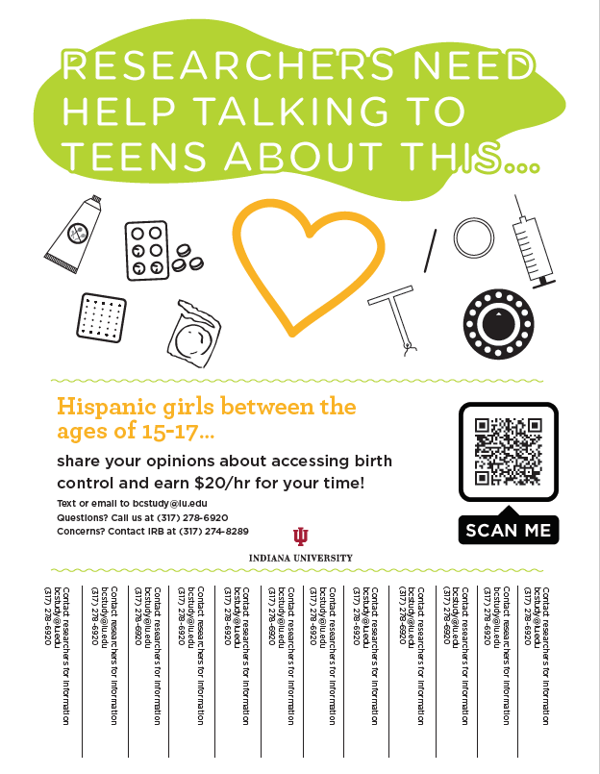
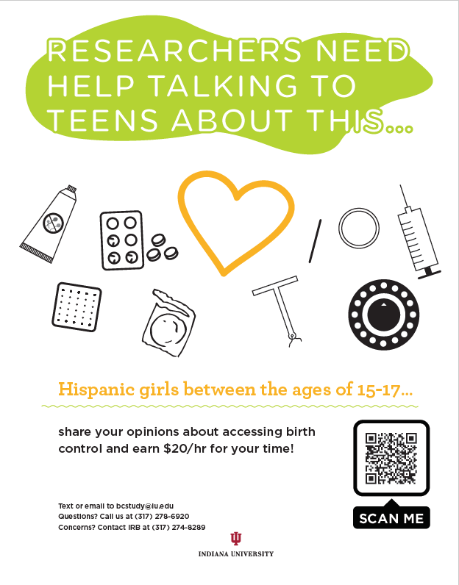

Appendix: 1707550885_Warden_FIT_facebok ads_rv2.pdf

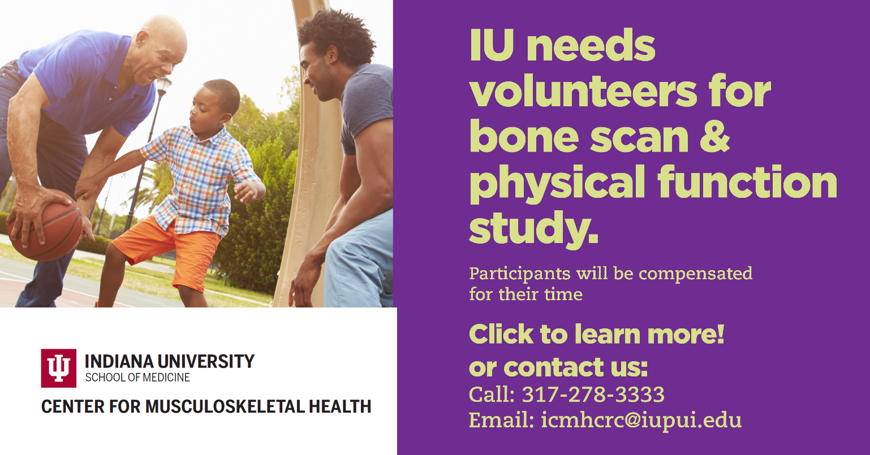

Appendix: 1707550885_Warden_FIT_Study_Brochure_rv5(1).pdf (2 pages)
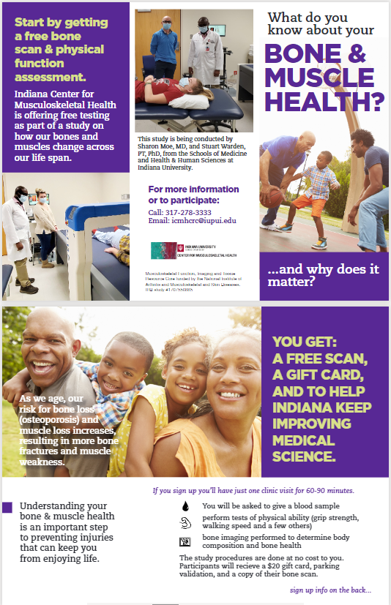

Appendix: EAZ171_RecMats_PatientSummaryTrifold_041219.pdf (2 pages)
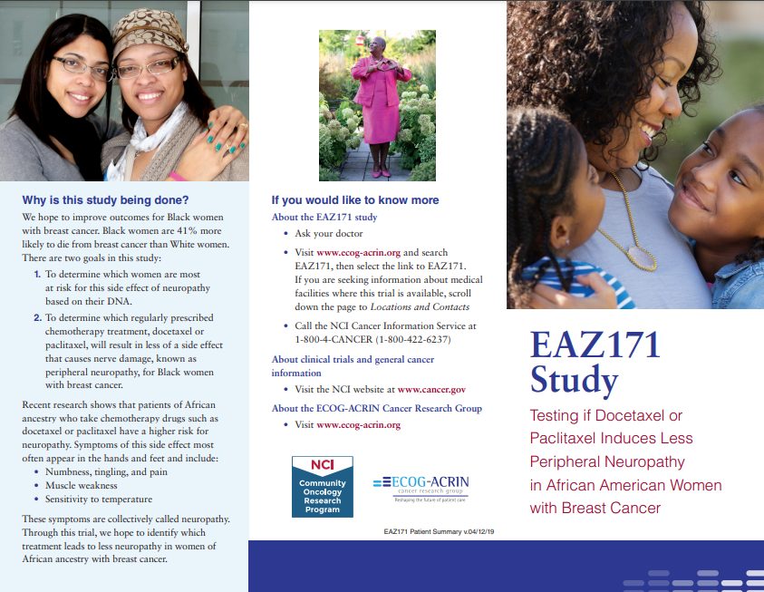
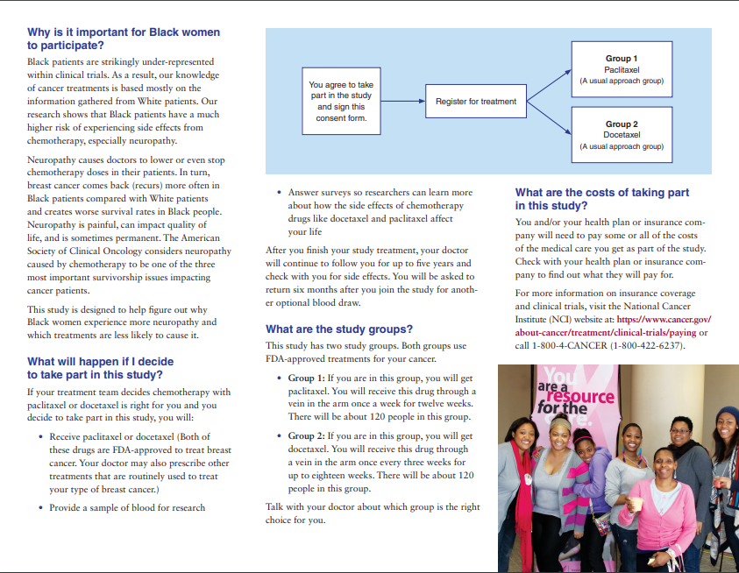

Appendix: Mythorfactv3.pdf (2 pages)
